UNMANNED AERIAL SYSTEMS

Skills Learned: Airfoil Theory, Aerodynamics &
Structural Design, Stability and Control, Sensors
NASWIHA NOWSHAD
B240077EC

Minor Course: Unmanned Aerial Systems

Airfoil Theory

1. Airfoils Selected for Analysis
The following airfoils were selected for aerodynamic comparison in the parent–child docking drone project:
- NACA 0012 airfoil
- NACA 2412 airfoil
- NACA 4412 airfoil
- S1223 airfoil
2. Software and Analysis Method
Airfoil analysis was performed using:
- XFLR5
The software was used for:
- Airfoil generation/import
- Polar analysis
- Lift and drag evaluation
- Aerodynamic efficiency comparison
- Pressure coefficient analysis

3. Airfoil Modeling Procedure

Step 1 — Airfoil Generation
NACA airfoils were generated using the built-in NACA foil generator in XFLR5.
S1223 airfoil was imported using DAT coordinate files.
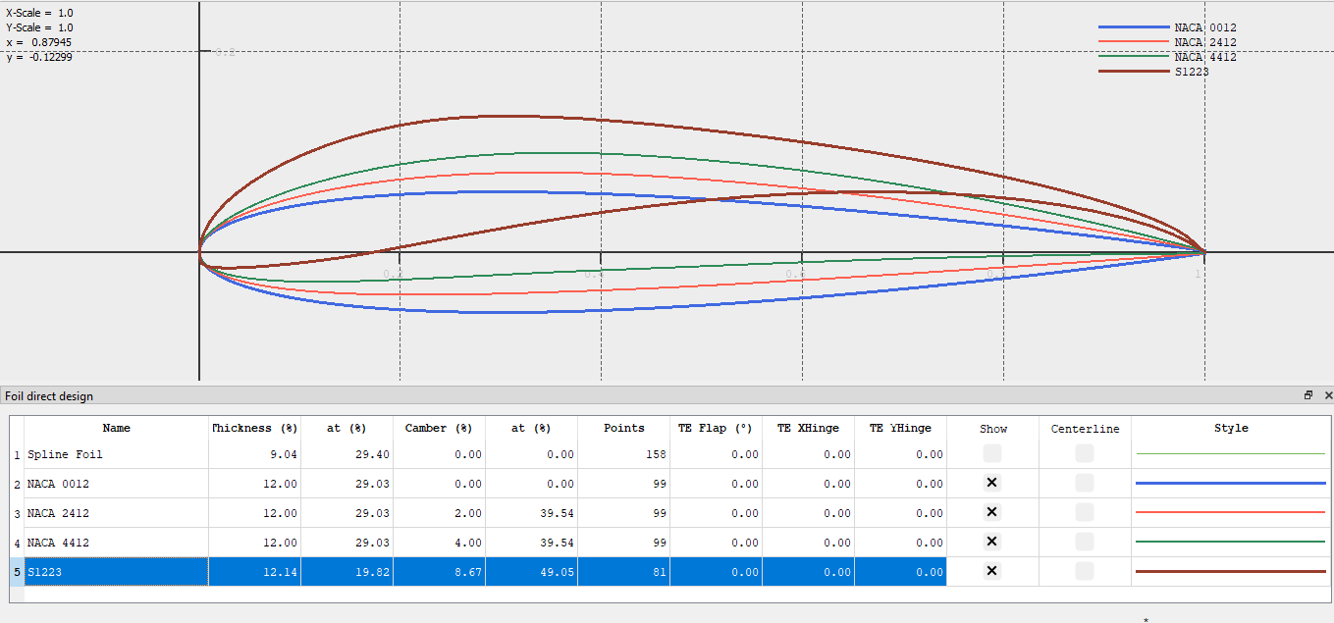

Step 2 — Polar Definition
Type 1 fixed-speed polar analysis was selected.
Parameters used:
Parameter | Value
Reynolds Number | 200000
Mach Number | 0
Ncrit | 9
Alpha Range | -5° to 15°
Increment | 0.5°

Step 3 — Aerodynamic Analysis
Aerodynamic analysis was executed for all selected airfoils under identical conditions.

Step 4 — Graph Generation
The following graphs were generated:
- Cl vs Alpha
- Cd vs Alpha
- Cl/Cd vs Alpha
- Pressure coefficient distribution (Cp)
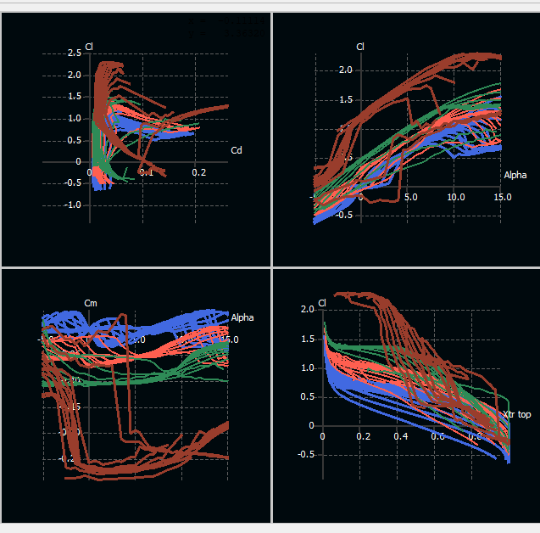

4. Lift Coefficient Analysis

Lift coefficient variation with angle of attack was analyzed for all selected airfoils.

Observations
- Lift coefficient increased approximately linearly with increasing angle of attack before stall.
- NACA 4412 generated higher lift compared to NACA 0012.
- S1223 produced the highest lift characteristics at low Reynolds numbers.
- NACA 0012 showed smoother and more symmetric behavior.

Comparison
Airfoil | Lift Characteristics
NACA 0012 | Moderate lift
NACA 2412 | Balanced lift
NACA 4412 | High lift
S1223 | Very high lift

5. Drag Coefficient Analysis
Drag coefficient variation with angle of attack was studied using polar analysis.

Observations
- Drag increased gradually with angle of attack.
- Significant drag rise occurred after stall angle.
- NACA 0012 showed lower drag at moderate angles.
- S1223 produced higher drag at larger angles due to stronger camber.

Comparison
Airfoil | Drag Characteristics
NACA 0012 | Low drag
NACA 2412 | Moderate drag
NACA 4412 | Slightly higher drag
S1223 | Higher drag at high alpha

6. Aerodynamic Efficiency Analysis
Lift-to-drag ratio analysis was conducted using Cl/Cd graphs.

Observations
- Maximum aerodynamic efficiency occurred at moderate angles of attack.
- NACA 2412 showed stable and balanced efficiency characteristics.
- S1223 exhibited excellent low-speed efficiency for UAV operation.
- NACA 0012 demonstrated predictable performance.

Comparison
Airfoil | Efficiency
NACA 0012 | Stable
NACA 2412 | Balanced
NACA 4412 | High lift efficiency
S1223 | Excellent low-speed efficiency

7. Pressure Distribution Analysis
Pressure coefficient (Cp) distribution was analyzed for selected operating points.

Observations
- Lower pressure regions were observed on the upper airfoil surface.
- Higher pressure regions were observed on the lower surface.
- Strong suction peaks were observed near the leading edge.
- Pressure difference between upper and lower surfaces contributed to lift generation.
8. Stall Behavior Analysis

Observations
- Stall behavior was identified from sudden reduction in lift coefficient.
- NACA 4412 and S1223 showed higher lift before stall.
- NACA 0012 demonstrated smoother stall characteristics.
9. Final Comparison of Airfoils

Airfoil | Lift | Drag | Stability | UAV Suitability
NACA 0012 | Moderate | Low | Excellent | Moderate
NACA 2412 | Balanced | Moderate | Good | Good
NACA 4412 | High | Moderate | Moderate | Very Good
S1223 | Very High | Higher | Moderate | Excellent

10. Conclusion
Airfoil analysis was successfully performed using XFLR5 for low-Reynolds-number UAV conditions relevant to the parent–child docking drone system.
Comparative aerodynamic analysis showed that:
- NACA 0012 provided stable and symmetric aerodynamic behavior.
- NACA 2412 demonstrated balanced lift and efficiency characteristics.
- NACA 4412 generated higher lift suitable for payload carrying applications.
- S1223 exhibited superior low-speed lift performance and UAV efficiency.
Based on the conducted analysis, cambered airfoils such as NACA 4412 and S1223 were found more suitable for low-speed UAV operations requiring improved lift generation and aerodynamic efficiency.

Aerodynamics and Structural Design

1. Software and Tools Used
The following software tools were used for aerodynamic and structural investigations:
- Fusion 360
- ANSYS Fluent
- ANSYS Workbench
2. CAD Modeling of Drone Structure
A simplified parent–child drone geometry was developed using Fusion 360.
The CAD model included:
- Central drone body
- Motor arms
- Propeller regions
- Docking section
- Child drone accommodation region
The geometry was simplified to improve CFD meshing and reduce computational complexity.

3. Aerodynamic CFD Analysis
Computational Fluid Dynamics (CFD) analysis was conducted in ANSYS Fluent to study airflow behavior around the drone structure.

CFD Procedure Performed

Step 1 — Geometry Import
The CAD model was exported as a STEP file and imported into ANSYS Workbench.

Step 2 — Fluid Domain Creation
An external air enclosure was generated around the drone body to simulate surrounding airflow conditions.

Step 3 — Meshing
A computational mesh was generated with finer mesh regions near:
- Drone body
- Arm junctions
- Docking interface

Step 4 — Boundary Conditions
The following conditions were applied:
Parameter | Value
Inlet Velocity | 10 m/s
Outlet | Pressure outlet
Solver Type | Pressure-based
Flow Type | Steady-state
Turbulence Model | k-ω SST

Step 5 — CFD Simulation
The solver was executed for multiple iterations until convergence.

Step 6 — Result Visualization
The following outputs were generated:
- Velocity contours
- Pressure contours
- Streamlines
- Turbulence regions

4. Aerodynamic Observations

Velocity Contours

Observations
- Higher airflow velocity regions were observed around arm edges and docking regions.
- Wake formation occurred behind the drone body.
- Flow acceleration was observed near narrow structural regions.

Pressure Distribution

Observations
- High-pressure regions formed at frontal surfaces.
- Low-pressure zones appeared along upper body surfaces.
- Pressure imbalance contributed to aerodynamic loading.

Streamline Analysis

Observations
- Streamline separation occurred near sharp geometry transitions.
- Disturbed flow regions were identified behind the docking interface.
- Smooth body curvature improved airflow continuity.

Turbulence Analysis

Observations
- Increased turbulence intensity was observed near docking structures.
- Rotor interaction regions produced disturbed airflow patterns.

5. Aerodynamic Comparisons

Comparison Between Structural Regions
Region | Aerodynamic Behavior
Rounded body surfaces | Smooth airflow
Sharp edges | Flow separation
Docking interface | Local turbulence
Arm junctions | Velocity concentration

6. Structural Design Analysis
Structural analysis was performed to evaluate:
- Stress concentration
- Structural deformation
- Load-bearing capability

Structural Analysis Procedure

Step 1 — Material Assignment
Lightweight structural materials were considered for UAV applications.
Example:
- Carbon fiber composite
- Aluminum alloy

Step 2 — Boundary Conditions
Fixed supports were applied near:
- Central frame regions
Loads were applied at:
- Motor mounting regions
- Docking interface locations

Step 3 — Static Structural Simulation
Static structural analysis was executed in ANSYS Workbench.

Step 4 — Output Generation
The following results were obtained:
- Equivalent stress plots
- Total deformation plots
- Structural displacement contours

7. Structural Observations

Stress Distribution

Observations
- Maximum stress concentration occurred near motor arm joints.
- Docking interface regions experienced localized stress loading.
- Stress remained within acceptable structural limits.

Deformation Analysis

Observations
- Small structural deformation was observed under loading conditions.
- Maximum deformation occurred near unsupported arm extremities.
- Central body region remained structurally stable.

8. Structural Comparisons
Structural Region | Stress Level | Deformation
Motor arm joints | High | Moderate
Central body | Low | Low
Docking interface | Moderate | Moderate
Outer arm sections | Moderate | Higher

9. Design Improvements Considered
The following improvements were identified during analysis:
- Increased reinforcement near arm joints
- Smoother aerodynamic transitions
- Reduced sharp edges near docking interface
- Improved load distribution across frame

10. Conclusion
Aerodynamic and structural investigations were successfully conducted for the parent–child docking drone system using Fusion 360 and ANSYS tools.
CFD analysis identified:
- Wake formation
- Turbulence regions
- Pressure concentration areas
- Airflow disturbances near docking regions
Structural analysis identified:
- Stress concentration near motor mounts
- Controlled structural deformation
- Stable central body behavior
The combined aerodynamic and structural studies contributed to optimization of:
- UAV stability
- Structural integrity
- Docking efficiency
- Aerodynamic performance
The performed simulations validated the feasibility of the proposed drone configuration for low-speed UAV docking operations.
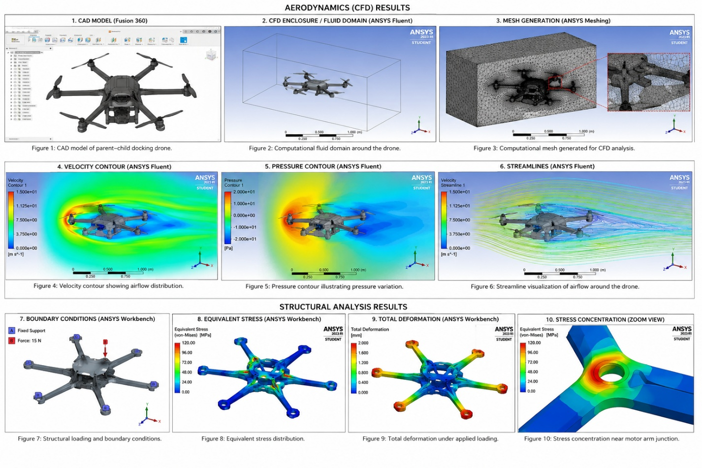

Stability and Control

1. Stability Parameters Studied
The following stability parameters of UAV systems were studied:
- Roll stability
- Pitch stability
- Yaw stability
- Hover stability
- Dynamic response characteristics
- Disturbance response
- Docking alignment stability

2. Roll Stability
The effect of roll motion on quadcopter balance and lateral stability was studied.
The relationship between:
- Motor thrust imbalance
- Roll angle variation
- Lateral motion
was analyzed.

Observations
- Small thrust variations between opposite motors caused roll motion.
- Excessive roll angle reduced flight stability.
- Oscillatory roll motion affected docking alignment accuracy.
- Balanced thrust distribution improved lateral stability.

3. Pitch Stability
Pitch dynamics during forward and backward motion were studied.
The effect of:
- Center of gravity location
- Thrust variation
- Drone geometry
on pitch stability was analyzed.

Observations
- Forward shift in center of gravity increased pitching tendency.
- Uneven thrust distribution produced unstable pitch motion.
- Stable pitch behavior improved docking precision.
- Aerodynamic disturbances affected pitch response during hover.

4. Yaw Stability
Yaw motion and directional stability of the drone were studied.
The influence of:
- Rotor torque
- Counter-rotating propellers
- Rotational balance
was investigated.

Observations
- Rotor torque imbalance caused yaw drift.
- Counter-rotating propellers improved directional stability.
- Sudden yaw motion affected docking orientation.
- Controlled yaw response improved alignment accuracy.

5. Hover Stability
Hovering conditions were studied to understand stability during stationary flight and docking operations.
The influence of:
- Wind disturbances
- Rotor wash interaction
- Small positional deviations
was analyzed.

Observations
- Hover instability increased docking difficulty.
- Rotor interaction generated local airflow disturbances.
- Small positional oscillations reduced docking precision.
- Stable hovering improved docking feasibility.

6. Dynamic Response Analysis
The transient response of the drone under disturbance conditions was studied.
The following behaviors were analyzed:
- Oscillatory response
- Settling behavior
- Response time
- Overshoot characteristics

Observations
- Sudden disturbances caused temporary oscillatory motion.
- Excessive oscillations reduced flight stability.
- Faster settling improved system controllability.
- Reduced overshoot improved stabilization behavior.

7. Center of Gravity Analysis
The effect of center of gravity position on flight stability was studied.
Different payload and docking configurations were considered.

Observations
- Off-center payload distribution reduced stability.
- Centralized mass distribution improved balance.
- Docking mechanisms influenced center of gravity location.
- Stable CG positioning improved hover performance.

8. Docking Stability
The stability requirements during parent–child docking operations were investigated.
The influence of:
- Relative alignment
- Hover precision
- Orientation stability
was analyzed.

Observations
- Small angular deviations affected docking accuracy.
- Stable roll and pitch behavior were essential during docking.
- Reduced oscillations improved alignment feasibility.
- Hover stabilization was critical for successful docking.

9. Comparative Stability Analysis
Parameter | Stable Configuration | Unstable Configuration
Roll Motion | Minimal oscillation | Large oscillation
Pitch Response | Smooth response | Sudden deviations
Yaw Stability | Controlled rotation | Drift motion
Hovering | Stable | Position fluctuations
Docking Alignment | Accurate | Misalignment

10. Key Findings
The conducted study identified that:
- Stable thrust distribution is essential for UAV balance.
- Hover precision directly affects docking success.
- Center of gravity plays a major role in stability.
- Roll and pitch oscillations significantly influence docking accuracy.
- Directional control is important for autonomous alignment.

11. Conclusion
The stability and control characteristics of the parent–child docking drone system were studied with emphasis on roll, pitch, yaw, and hover behavior.
The conducted research showed that:
- Stable thrust balance improves flight control.
- Controlled attitude response improves docking precision.
- Hover stability is critical for autonomous docking operations.
- Proper center of gravity distribution enhances UAV stability.
- Reduced oscillatory behavior improves overall controllability.
The study validated the importance of stable attitude control and dynamic balance for reliable parent–child docking drone operations.

Sensors

1. Sensors Studied for the Drone System
The following sensors relevant to the parent–child docking drone system were studied:
- Ultrasonic sensor
- Infrared (IR) sensor
- IMU (Accelerometer + Gyroscope)
- GPS module
- Barometer
- Magnetometer
- Camera/Vision sensor
The study focused on:
- Navigation
- Stabilization
- Position estimation
- Hover control
- Docking assistance
- Relative alignment

2. Ultrasonic Sensor Study
Ultrasonic sensing was studied for:
- Obstacle detection
- Distance measurement
- Docking proximity estimation
The working principle based on ultrasonic pulse transmission and echo reception was analyzed.

Observations
- Accurate short-range distance measurement was obtained.
- Sensor performance decreased at larger distances.
- Surface irregularities affected echo response.
- Useful for close-range docking alignment.

3. Infrared (IR) Sensor Study
Infrared sensing was studied for:
- Short-range object detection
- Docking position sensing
- Relative positioning assistance

Observations
- Fast response time was observed.
- Detection accuracy reduced under strong ambient lighting.
- Effective for short-range alignment applications.
- Useful for close docking guidance.

4. IMU Sensor Study
The Inertial Measurement Unit (IMU), consisting of accelerometer and gyroscope sensors, was studied for:
- Orientation sensing
- Attitude stabilization
- Motion tracking
The influence of IMU feedback on flight stability and hover control was analyzed.

Observations
- Gyroscope measured angular motion effectively.
- Accelerometer detected linear acceleration and tilt.
- Combined sensor fusion improved orientation estimation.
- IMU data was essential for stable flight control.

5. GPS Sensor Study
GPS-based positioning was studied for:
- Global navigation
- Outdoor positioning
- Path tracking

Observations
- GPS enabled long-range position estimation.
- Accuracy reduced in indoor or obstructed environments.
- Useful for large-scale navigation.
- Limited precision for close docking operations.

6. Barometer Study
Barometric sensing was studied for:
- Altitude estimation
- Hover stabilization
- Vertical position control

Observations
- Atmospheric pressure variation enabled altitude estimation.
- Small pressure fluctuations affected accuracy.
- Useful for maintaining stable hover altitude.
- Improved vertical positioning capability.

7. Magnetometer Study
Magnetometer sensing was studied for directional orientation and heading estimation.

Observations
- Magnetic field sensing improved directional awareness.
- Nearby electronic interference affected readings.
- Useful for yaw orientation stabilization.
- Assisted in navigation alignment.

8. Vision Sensor / Camera Study
Camera-based sensing was studied for:
- Visual docking assistance
- Object recognition
- Relative positioning
The role of vision sensing in autonomous docking and alignment was investigated.

Observations
- Vision sensing improved alignment capability.
- Lighting conditions affected detection quality.
- Image processing increased computational requirement.
- Useful for autonomous docking guidance.

9. Sensor Interfacing Study
Sensor interfacing methods and communication protocols were studied for reliable integration with flight controllers and embedded systems.
The following interfaces were analyzed:
- I2C communication
- SPI communication
- UART communication

Observations
- I2C communication simplified multi-sensor interfacing.
- UART communication was suitable for GPS modules.
- SPI communication provided faster data transfer rates.
- Proper sensor interfacing improved data reliability.

10. Sensor Fusion Study
The integration of multiple sensors for improved drone performance was studied.
The following combinations were investigated:
- IMU + GPS
- IMU + Barometer
- Camera + Ultrasonic sensor
Basic concepts of sensor fusion and combined sensing were analyzed.

Observations
- Sensor fusion improved stability and positioning accuracy.
- Combined sensing reduced individual sensor limitations.
- IMU and barometer improved hover stability.
- Vision and distance sensing improved docking precision.

11. Signal Noise and Filtering Study
The effect of signal noise and vibration disturbances on sensor readings was studied.
Basic filtering concepts for UAV sensing systems were investigated.

Observations
- IMU readings were sensitive to vibrations.
- Electrical noise affected sensor accuracy.
- Filtering improved signal stability.
- Noise reduction improved flight stabilization performance.

12. IMU Calibration Study
The importance of IMU calibration for accurate orientation sensing was studied.
The following factors were analyzed:
- Gyroscope drift
- Accelerometer bias
- Sensor offset errors

Observations
- Uncalibrated sensors produced inaccurate orientation estimation.
- Gyroscope drift accumulated over time.
- Calibration improved flight stability and positioning accuracy.
- Accurate calibration improved docking alignment precision.

13. Docking Sensor Requirements
Sensor requirements for autonomous parent–child docking operations were analyzed.
The influence of:
- Relative positioning
- Distance estimation
- Orientation sensing
- Hover stabilization
was studied.

Observations
- Close-range sensing is essential during docking.
- Orientation sensing improves alignment accuracy.
- Multiple sensor integration improves reliability.
- Hover stability depends strongly on IMU feedback.
- Vision-based sensing improves autonomous docking feasibility.

14. Comparative Sensor Analysis
Sensor | Main Function | Advantages | Limitations
Ultrasonic | Distance sensing | Accurate short-range sensing | Limited range
IR Sensor | Proximity sensing | Fast response | Sensitive to lighting
IMU | Orientation sensing | Essential for stabilization | Drift errors
GPS | Position tracking | Long-range navigation | Low close-range precision
Barometer | Altitude sensing | Hover stabilization | Pressure fluctuation sensitivity
Magnetometer | Direction sensing | Heading estimation | Magnetic interference
Camera | Visual guidance | Accurate alignment | Lighting dependency

15. Key Findings
The conducted sensor study identified that:
- IMU sensors are critical for flight stabilization.
- Ultrasonic and IR sensors are useful for close-range docking.
- GPS is effective for navigation but insufficient for precise docking.
- Vision sensing improves alignment accuracy.
- Sensor fusion significantly improves overall system reliability.
- Signal filtering improves sensing accuracy and flight stability.
- Proper sensor calibration is essential for reliable UAV operation.

16. Conclusion
The sensor systems relevant to the parent–child docking drone project were studied with emphasis on navigation, stabilization, altitude estimation, and docking assistance.
The conducted research demonstrated that:
- IMU sensors are essential for stable UAV operation.
- Distance sensors improve close-range docking capability.
- Vision sensing enhances autonomous alignment.
- Sensor fusion improves positioning accuracy and flight reliability.
- Signal filtering and calibration improve sensing accuracy.
- Integrated sensing systems are necessary for successful autonomous docking operations.
The study validated the importance of combining multiple sensing technologies for stable and reliable parent–child drone docking applications.

